SECOND FACTOR ANTI-AMERICAN GLOBALIZATION:

If you are member of an international organization that has established a “service” that creates money out of nothing, makes loans, and charges interest on those loans, you would want to establish that banking racket world wide.
However, with poor undeveloped countries, like China used to be and Afghanistan is now, there is no profit potential. But if money could somehow be diverted from rich countries and used to industrialize poor countries along with establishing an international banking system, then the profit potential is huge.
Afghanistan has taken so long, over 17 years, because of the Koran. Most Muslims believe that it prohibits collecting any interest on a loan or savings account. That makes establishing a banking system very difficult and credit cards, well, impossible. (25)
From Reuters in 2018: “Afghanistan’s banking sector is small, but Islamic finance is seen as an important feature that could help attract more people into the financial system. The Islamic Bank of Afghanistan estimates that only 5.7 percent of the population has dealings with the banking sector.” (23)

“Since 2001, Washington has spent more on nation-building in Afghanistan than in any country ever, allocating $133 billion for reconstruction, aid programs and the Afghan security forces.” (24) And you better believe that there were plenty of the well connected rich establishment that took their cut. But that achieved only a 5.7% bank participation rate after over 17 years of nation building! Even if that was up from zero, the international banking cartel has to be very disappointed.

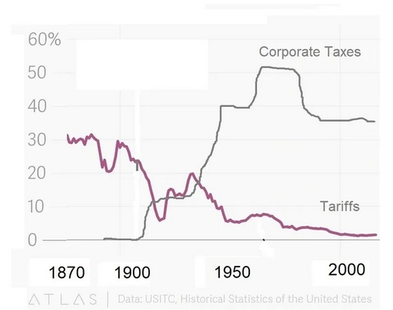

(14)

Before the Federal Reserve act and the 16thamendment in 1913, federal personal and corporate taxes were zero and tariffs averaged about 20% giving domestic production a considerable advantage over foreign production of goods sold in the US. These protectionist policies were admittedly unfair. However, by 1952 corporate taxes had gone up dramatically to above 50% and tariffs, the tax on foreign production, went down to 5%. The addition of personal income taxes increased the cost of labor. This punished domestic production and gave a huge advantage to foreign production. This was totally unfair in the opposite direction. Why would any president or congress go along with that for over 60 years? This was the case even for past Republican administrations.
Anti-American Globalization actually started taking effect in the 1960s especially with Japanese imports. This was offset by government spending on the space race which made the Aerospace Cutback so dramatic.
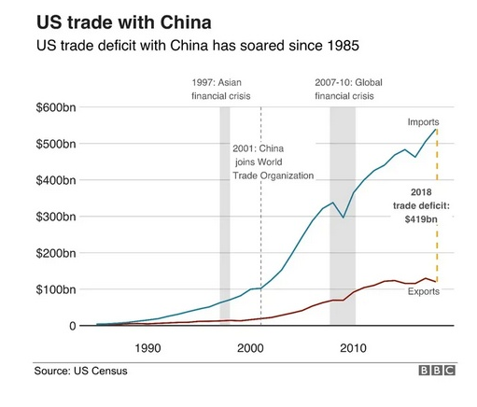

(33)

The result is a trade deficit with China of $420 billion in 2018. Paul Krugman and other mainstream trade experts are now admitting that they were wrong about globalization: It hurt American workers far more than they thought it would. (36)
Actually the goal of he Globalists seems to be worldwide economic enslavement. I suspect that the same Hourly Compensation vs Worker Productivity graph in many other countries would look just like ours.
I offer as evidence the fact that homelessness has become a world wide problem. Even Australia, Canada, France, Germany, Greece, Ireland, New Zealand, and the United Kingdom have a higher homeless rate than the United States! (42)
Again, a fundamental principle of a natural economy is: Advancing technology results in increased worker productivity which produces more wealth and results in a higher average standard of living.

